3. Write a pig script to find list of companies topping in complaint chart (companies with maximum number of complaints)

//query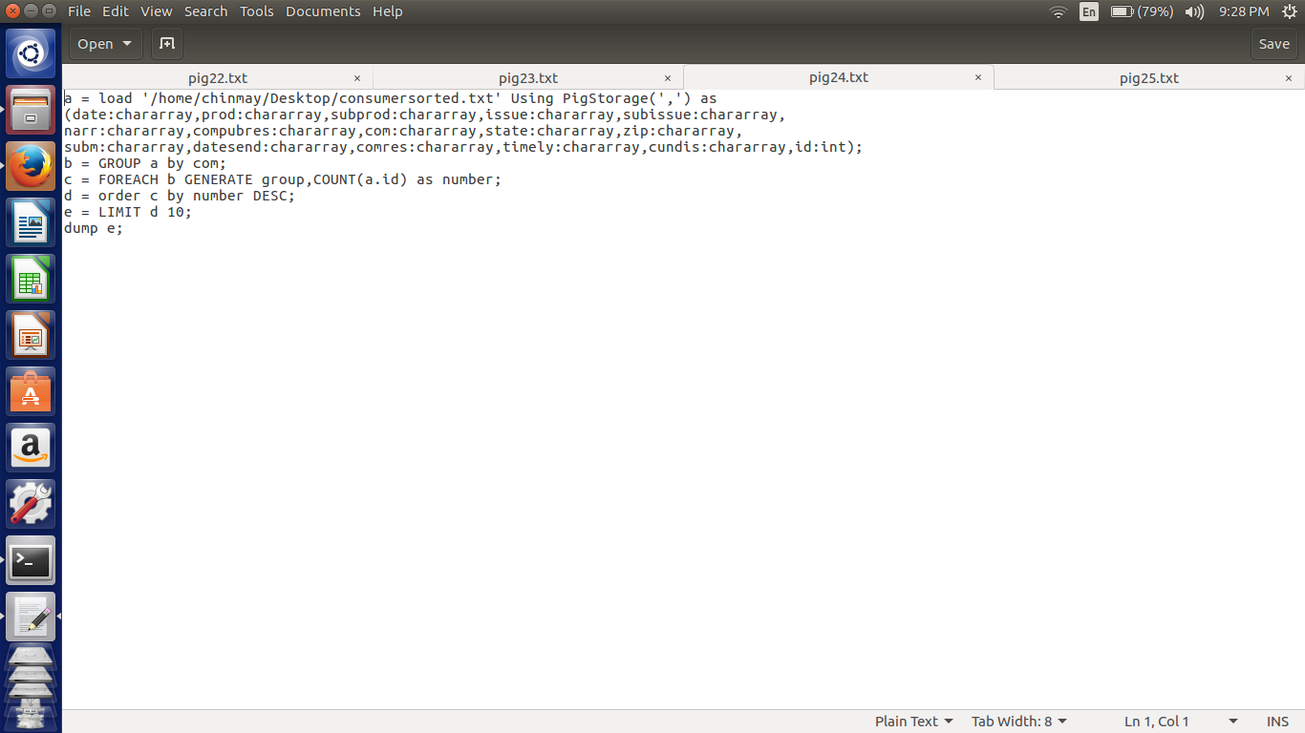

Here in this script first we are loading the file according to respective datatypes. First grouped by the company name .

Then generate the group and count of ids in the each group.

Now arranging the results in the descending order and limit the results to top 10.

//implementation

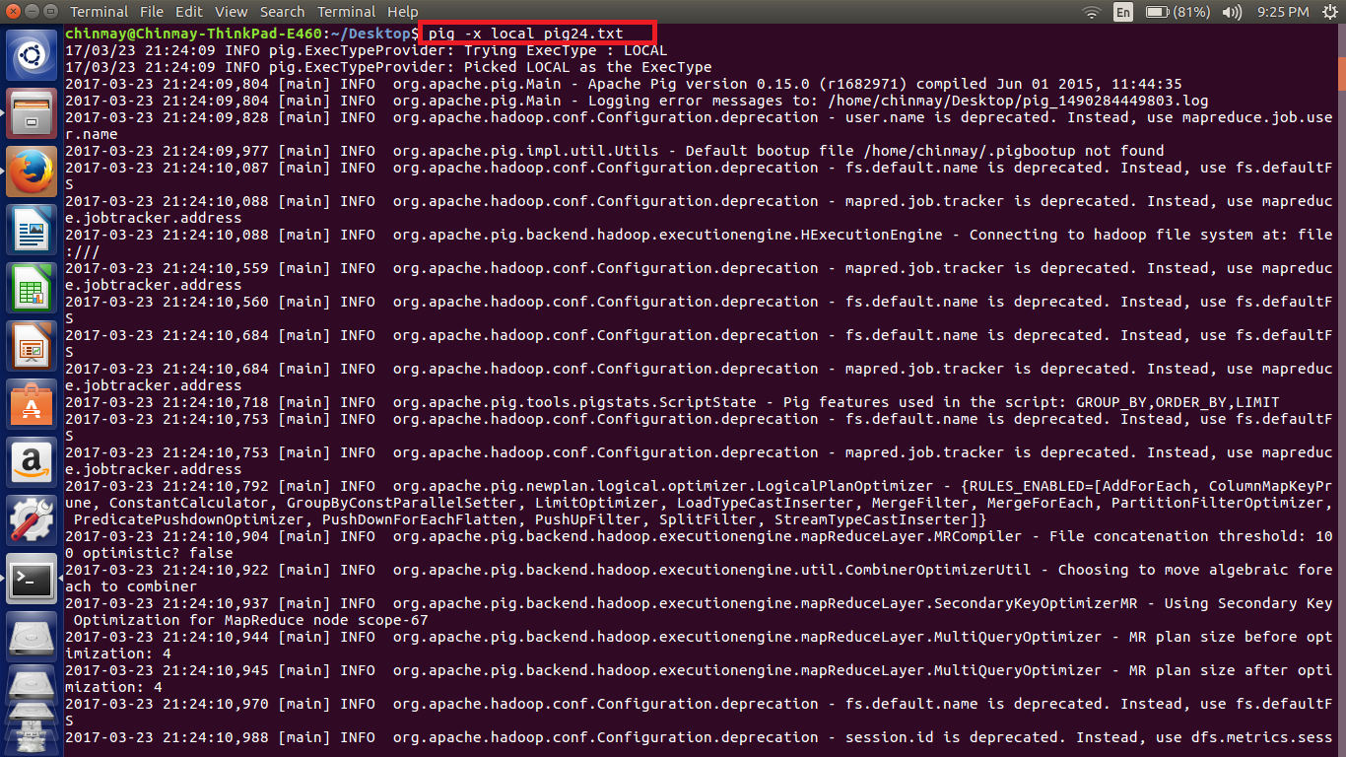

//output

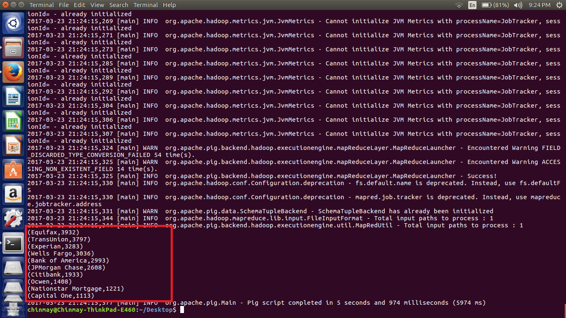

***NOTE - The file used for the implementation is also attached.***